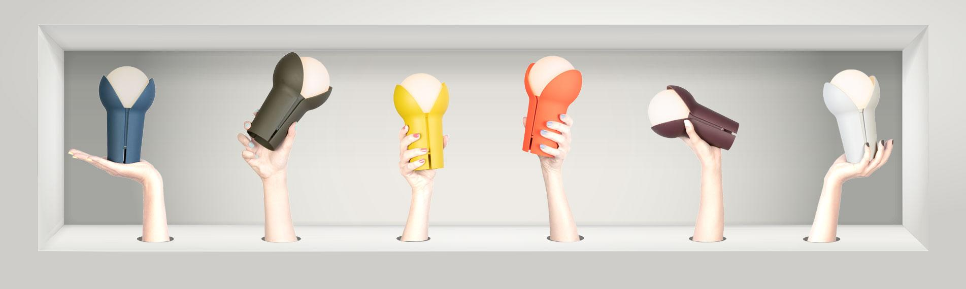
Ready, Set, Get Bud
To celebrate the arrival of their much anticipated cordless lamp, Innermost will be running some special promotions for ‘Bud’ throughout London Design Festival 2019.
Offering visitors to LDF a huge 50% discount on this go-anywhere do-anything LED lamp. Anyone through the doors of the Innermost showroom at the Oxo Tower during the festival can grab Bud for £50 instead of the usual £100.

Bud 321 Giveaway!

To celebrate the late night opening of Bankside Design District on Wednesday 18th September, they are also giving away Bud lamps to the first visitors through the door at 6pm!

First 3 visitors get a Bud for free!
Next 2 visitors get Bud at 80% off (£20)
Next 1 visitor gets Bud at 70% off (£30)
All other visitors receive the 50% off LDF promo (£50)

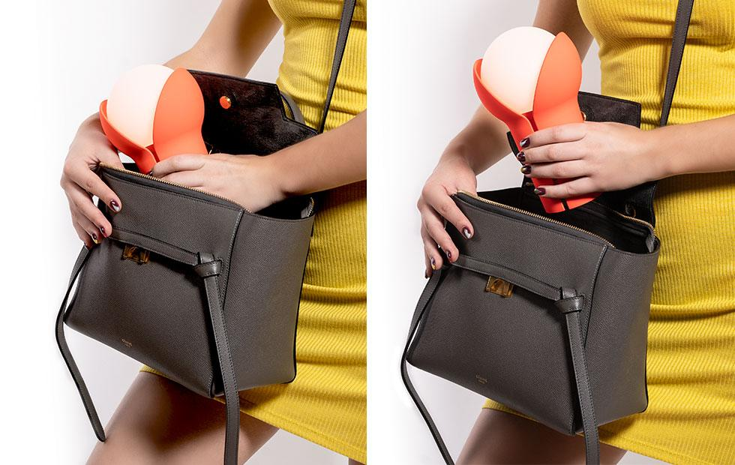

Simply visit the Innermost showroom during LDF and be the first to get your hands on these rechargeable, portable and fun cordless lamps, designed for Innermost by Melissa Yip.

Available in 6 bold colours; ocean, olive, lemon, fluoro, aubergine and ash.

London Showroom | 2.02 & 2.04 Oxo Tower Wharf Bargehouse Street | London | SE1 9PH
T: +44 (0)20 7620 1808
London Design Festival | Tuesday 17th to Friday 20th September | 10am to 6pm each day.
Late night Wednesday until 8pm

About Bud

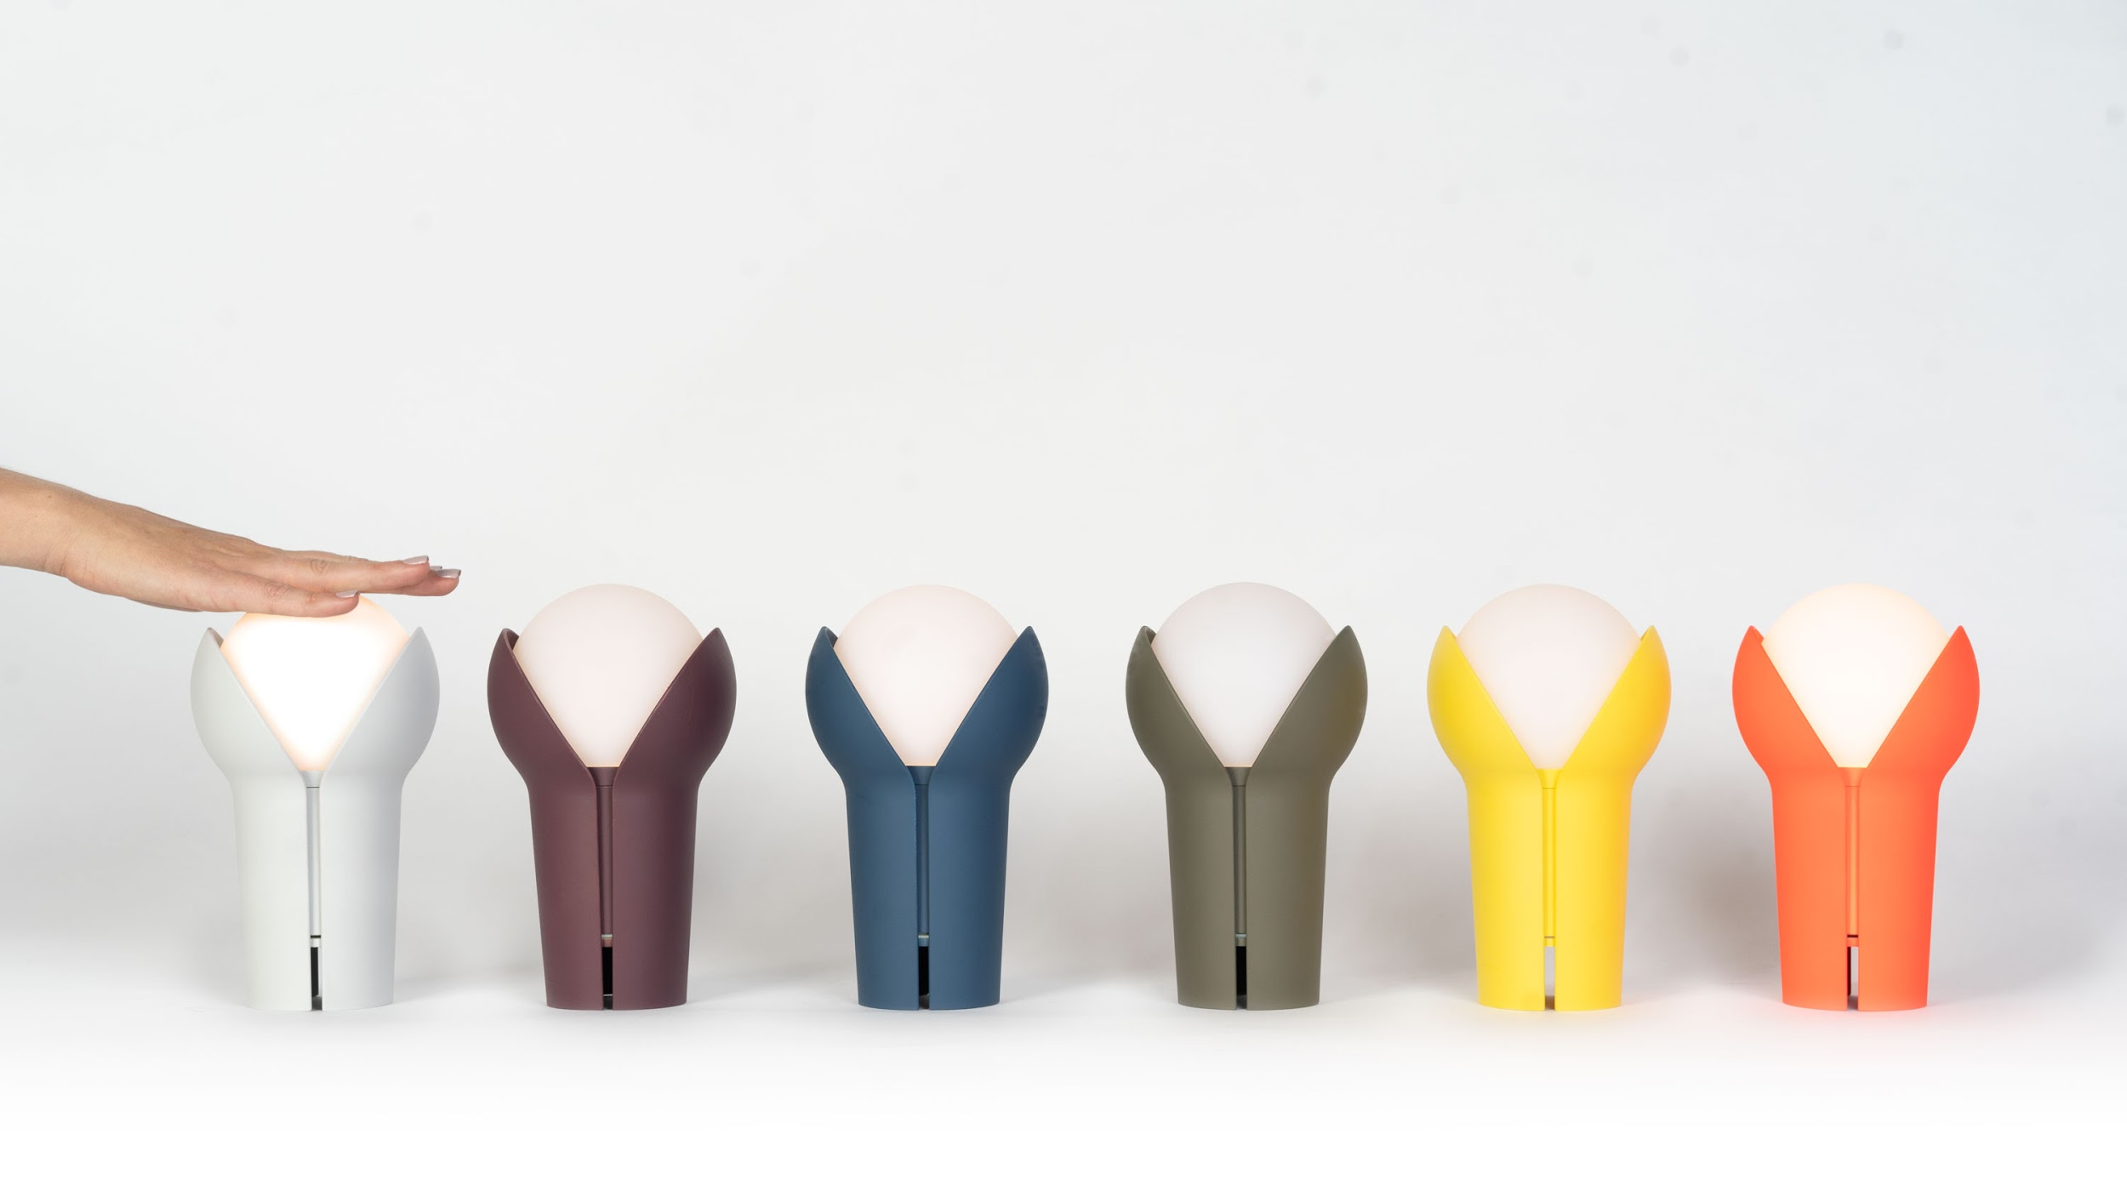

Whether illuminating a night picnic, a romantic rooftop dinner or any stylish interior, this rechargeable portable lamp frees you from the constraints of cables, with a three step dimming function to adjust to any situation.

Imitating nature, the globe bulb is shelled by two petal-like forms which appear to simultaneously hold and protect the light. It can be likened to a pearl in a shell, or plant in bloom, two petals hugging the light. The curvaceous design suggesting a form that is still in its infancy, protecting the light source inside.

With a vibrant range of colour options and beautiful box packaging, Bud is strikes the perfect balance between battery power, light output, longevity and price.

Additional details

- Available in 6 colours; ocean, olive, lemon, fluoro, aubergine and ash.
- IP 20 (for use in dry locations)
- Micro USB Cable (included)
- 20 hours maximum battery life (5hr battery life at 100%, 10hr at 50%, 20hr at 25%)

About Innermost
Innermost is a British design brand with a rebellious approach to lighting and furniture. Founded in London and working with designers from all over the world, Steve Jones and Russell Cameron aimed to create an innovative and diverse brand, making products of the absolute highest quality. Since 1999 the company has followed its initial philosophy, to be ‘as British as London itself’: a unique mixture of classic English tradition and vibrant global diversity.

For more information contact: emma@innermost.net or info@innermost.net
London Showroom - 2.02 & 2.04 Oxo Tower Wharf Bargehouse Street London SE1 9PH T +44 (0)20 7620 1808
Asia Sales Office - Unit 02, 2/F, EW International Tower, No. 120 Texaco Road, Tsuen Wan, Hong Kong T +852 2857 5289

